Readme – Grazioso Salvare Dashboard
Author: Cecily Boucher

- Introduction
This dashboard is designed to help Grazioso Salvare find dogs at shelters that could benefit from various rescue training programs. It provides an easy-to-use interface that shows a list of shelter animals, along with options to filter the results. Additionally, there's a pie chart to visualize specific information and a map to help locate each dog.

- Required Functionality
The dashboard shows essential information about dogs from our database. Here’s what it includes:
- A list of all the dogs available
- Options to filter the dogs based on their special skills, such as:
- Water rescue
- Mountain or wilderness tracking
- Disaster or individual tracking
- A reset button to clear the filters
- When you filter the dogs, the data table will update automatically
- If you click on a dog, a map will show its location
- A pie chart will display data related to dogs
- The Grazioso Salvare logo is featured
- My name is also included

Screenshots Required:
Screenshot 1: Water Rescue Filter
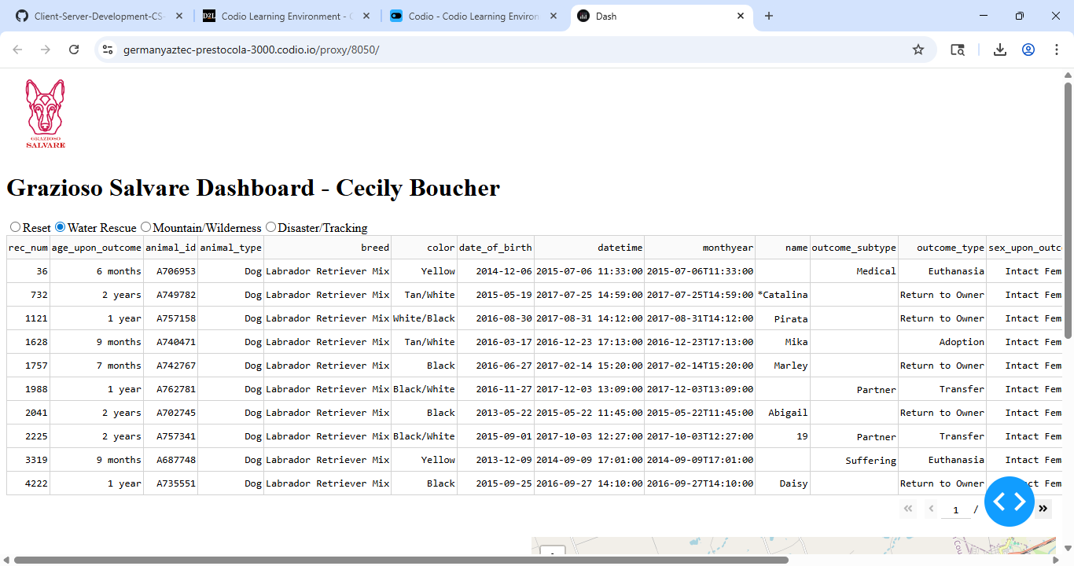
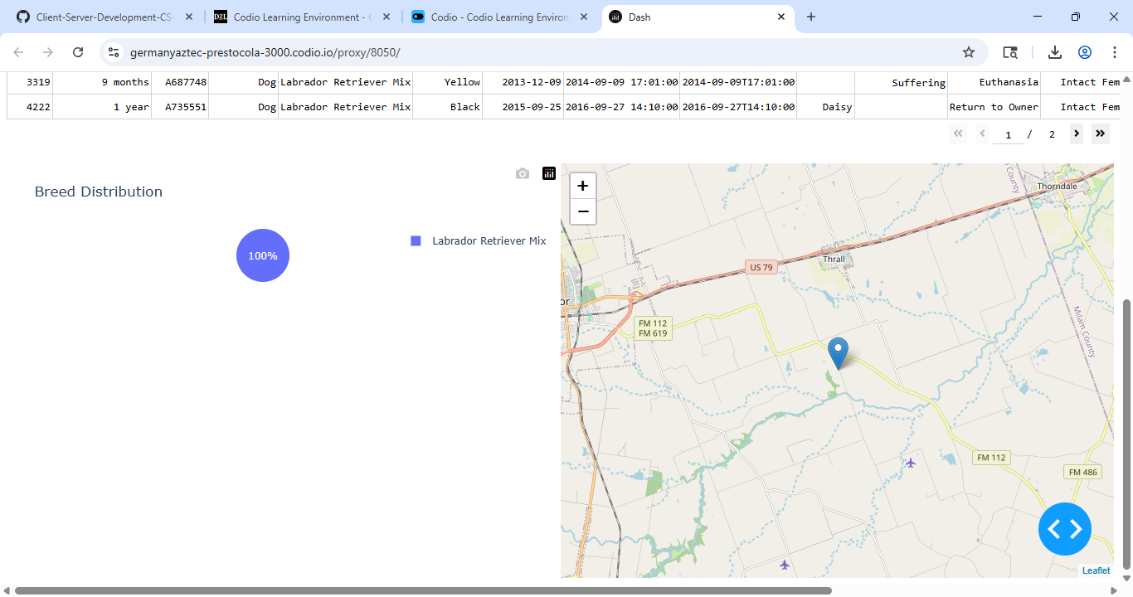
Screenshot 2: Mountain/Wilderness filter
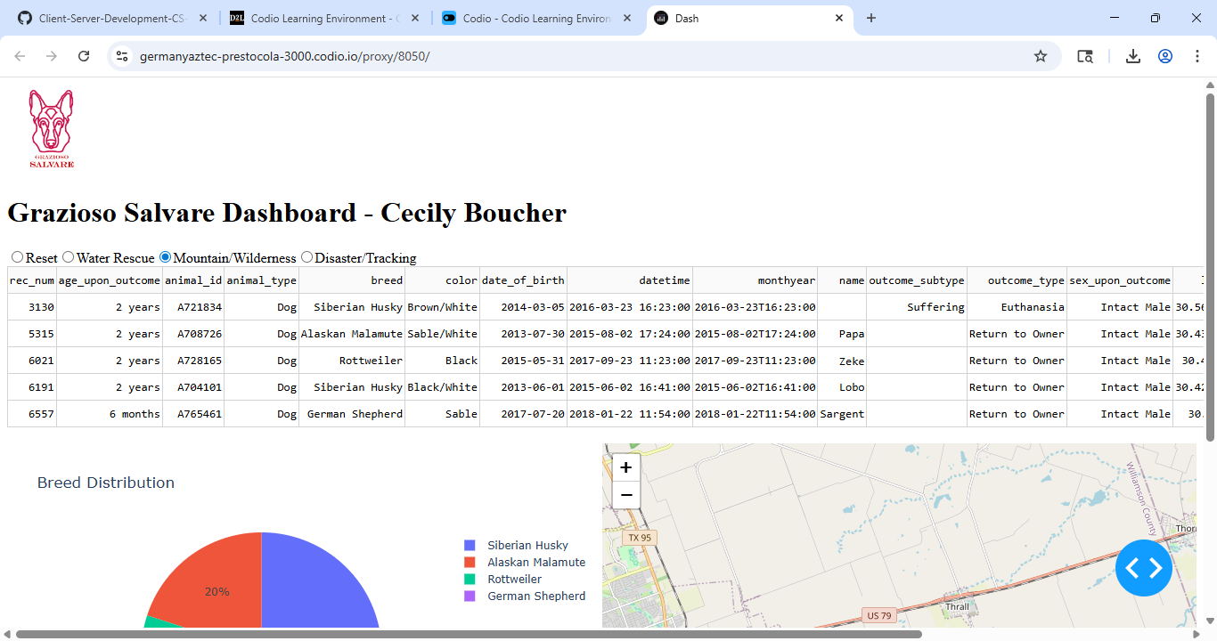
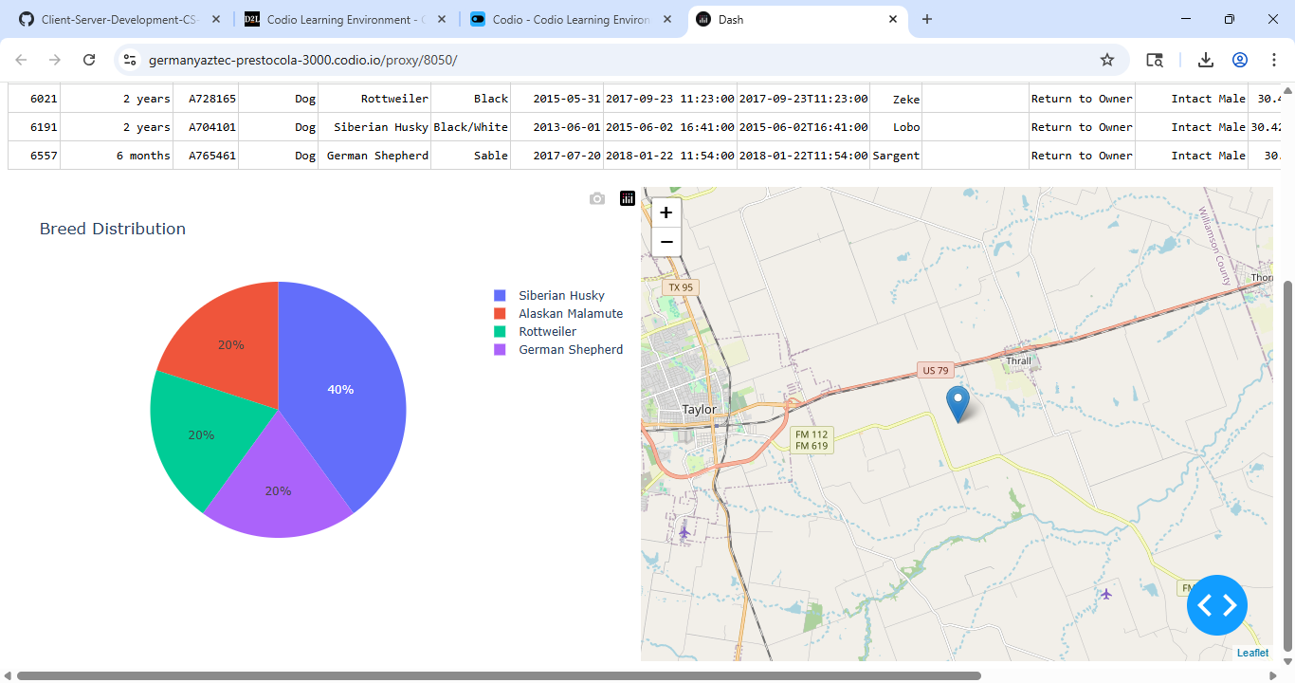
Screenshot 3: Disaster/Tracking filter
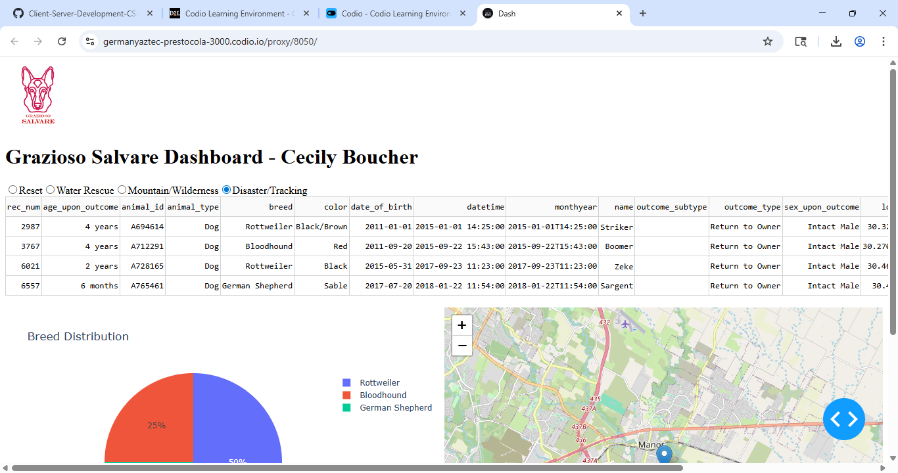
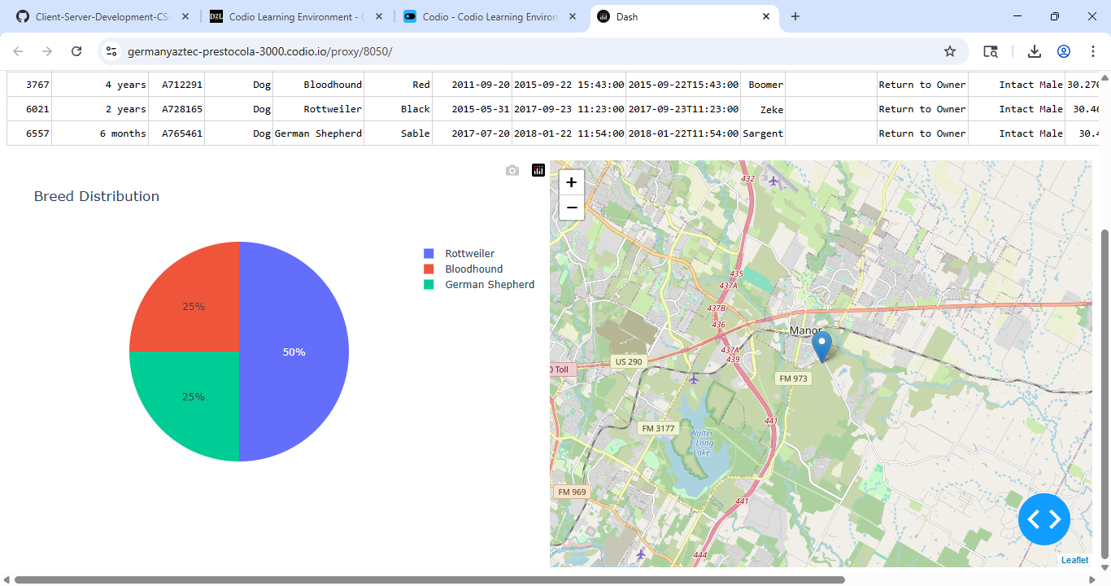
Screenshot 4: Reset filter
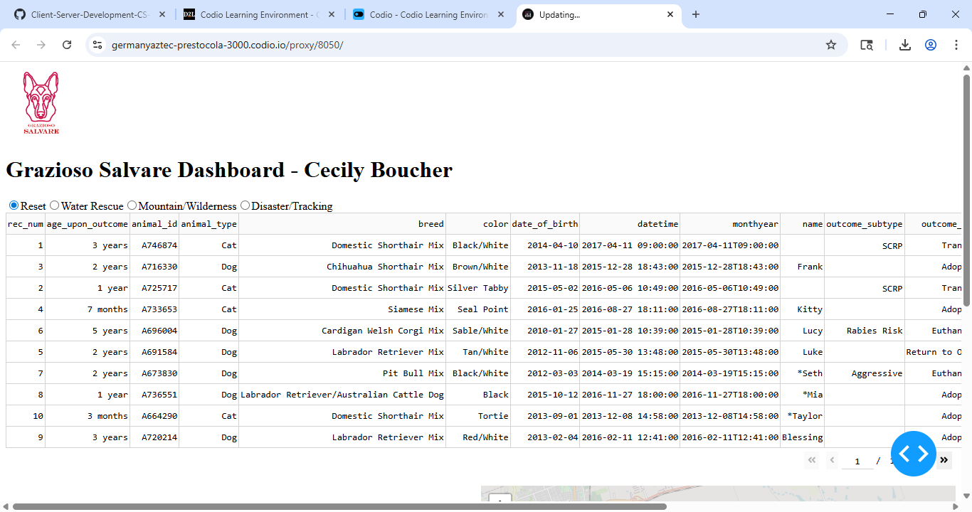
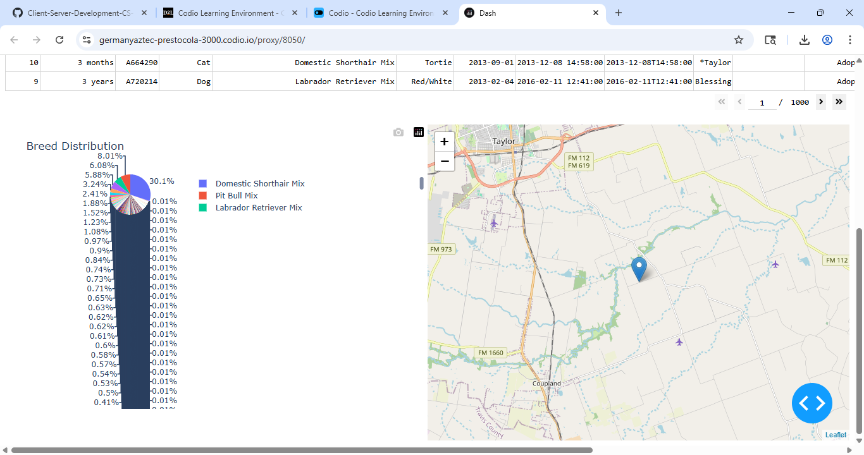

- Tools Used
MongoDB
We use MongoDB as our data storage system because it stores data in JSON format, which is easy to work with in Python. This allows us to perform actions such as creating, reading, updating, and deleting data without using complex SQL.
Dash
Dash is part of the system the user interacts with. It helps us build user-friendly elements like buttons, tables, and graphs for the application. One great feature of Dash is that it can automatically update the screen in response to user interactions through special functions called callbacks.
JupyterDash
JupyterDash lets us run our Dash application directly in the Codio Jupyter Notebook, making development and testing easier.
Pandas
Pandas is a tool we use to convert MongoDB results into a DataFrame. This allows Dash to display data easily in tables and charts.
Dash Leaflet
This component helps us display maps and indicate specific locations, such as where a dog is, on those maps.
Plotly Express
Plotly Express is used to create visualizations, such as pie charts, from filtered data, enabling a more precise understanding of the information.

- Steps Taken
- Installed a tool for managing data easily
- Set up a connection to a database
- Gathered information from the database
- Showed the information in a table format
- Included options to filter the data
- Developed specific requests to access different types of rescue information
- Updated the table based on selected filters
- Created a pie chart to visualize data
- Added a map for geographical representation
- Included a logo and title for branding
- Conducted tests to ensure everything works smoothly
- Captured screenshots for documentation

- Challenges

Map Not Showing
Some dogs' location information was missing, which meant their positions couldn't be shown on the map. I solved this issue by setting a standard location to use when the information wasn't available.
Logo File
The location of the logo file needed to be updated so that the program could locate it in the Code Files folder.
Rescue Queries
I had to closely review the guidelines in the Dashboard Specifications to create the appropriate database queries for each rescue type.

- Instructions for Reproducing

- Start by opening the file named “ProjectTwoDashboard.ipynb” in the Codio program.
- Next, run all the steps in the file.
- After a moment, look for a link that will take you to the Dash app.
- Click on that link.
- Once you’re on the app, choose the filters you want to apply.
- Finally, click on the rows in the table to see the related map.

- Resources
- Course materials from Southern New Hampshire University (SNHU)
- Official guide for using MongoDB (a type of database)
- User guide for Dash (a tool for building web applications)
- A PDF document outlining the specifications for the dashboard

- Conclusion
This dashboard meets all the project's needs and provides a user-friendly interface for Grazioso Salvare to find dogs in need of rescue training. It features useful tools, filtering options, interactive visuals, a colorful pie chart, a map, the Grazioso logo, and my name.

